Global Education Investment vs Economic Output (2012-2022)

0. Project Context
The Problem: The ROI of Human Capital
Global economic inequality remains a systemic challenge. While the consensus among international bodies is that education is the primary "lever" for upward mobility, the actual Return on Investment (ROI) of national education spending is rarely quantified. Governments allocate trillions of dollars to education, but do these fiscal efforts translate into immediate economic prosperity?
The Objective
This project analyzes a decade of global data to bridge the gap between fiscal input (spending as a % of GDP) and economic output (GDP per Capita and Purchasing Power Parity).
The Core Question
Does increased investment in education act as a leading indicator for improved global economic conditions? To answer this, I processed 10 years of longitudinal data to identify if wealth is a byproduct of education, or if education is a luxury afforded by existing wealth.
Analytical Hypotheses
To guide the study, I formulated three distinct hypotheses to be tested against the World Bank dataset:
- H0: There is no statistically significant correlation between a nation’s education spending (% of GDP) and its economic output (PPP). Any observed wealth is independent of fiscal investment in human capital.
- H1: Higher education spending as a percentage of GDP leads directly to higher GDP per Capita and PPP within a 10-year window.
- H2: Education investment is a "floor" metric; it prevents economic collapse in developing nations but does not immediately accelerate wealth.
- H3: Education is a necessary but insufficient driver. Wealth is only achieved when high investment is paired with institutional efficiency (The "21% Efficiency" theory).
1.1 Data Origin
The dataset was synthesized from the World Bank Open Data repository, covering 190+ countries. While the raw data spanned 50 years, this study focuses on a 10-year longitudinal window (2012–2022) to ensure data consistency and modern economic relevance.
1.2 Metric Selection
Metric | Definition | Strategic Purpose
Education Investment (% of GDP) | Total government expenditure on education as a share of the national GDP. | Normalizes "Fiscal Effort," allowing for a fair comparison between small and large economies.
GDP Per Capita (Current US$) | Gross Domestic Product divided by mid-year population. | Provides a baseline for raw economic output and national wealth.
PPP of GDP Per Capita | GDP per capita converted to international dollars using Purchasing Power Parity rates. | Primary Success Metric: Accounts for the relative cost of living and inflation, offering a true "standard of living" comparison.

1.3 Data Limitations
No dataset is perfect. To maintain analytical integrity, the following constraints were identified:
- High-Level Focus: The data measures quantity of spending, not quality of curriculum or institutional efficiency.
- The "Human Capital" Lag: Education ROI typically takes 15–20 years to manifest; a 10-year window captures immediate correlations but may miss long-term generational shifts.

2. Technical Workflow (ETL & Analysis)
To ensure data integrity, the project followed a structured four-stage workflow: Extraction, Cleaning, Transformation, and Visualization.
2.1 Data Cleaning & Normalization (Excel)
Raw World Bank data is optimized for readability, not analysis. The following steps were taken to prepare the data for SQL:
- Unpivoting: Restructured longitudinal data from wide format to long format to enable time-series analysis.
- Entity Classification: The raw "Country" column contained mixed data (individual nations and geographic regions). Created an Entity Type column using logical formulas to isolate countries from aggregate regions.
- Gap Analysis: Standardized blank fields to ensure smooth importation into the database.
2.2 Data Transformation & KPI Calculation (MySQL)
Cleaned data was imported into MySQL for heavy-duty transformation and KPI validation.
- Time-Series Logic: Created previous_year and yoy_diff columns using window functions to calculate Year-over-Year (YoY) growth in both absolute and percentage terms.
- Dynamic Benchmarking: I used Window Functions to calculate global and regional medians per year, which allowed for the creation of the is_above_avg binary flag used to identify the "Efficiency Quadrant".
- Validation: Used SQL queries to pre-calculate the study’s primary KPIs, ensuring the Power BI model would have a verified "source of truth."
2.3 Modeling & DAX Engineering (Power BI)
The final analysis was conducted in Power BI, utilizing a Star Schema for optimal performance.
- The "Investment Efficiency" Metric: Developed a custom DAX measure analogous to ROI. This metric filters for countries achieving a "Dual-High" status (spending > median AND PPP > median), which became the cornerstone of the study’s findings.
- Interactive Dashboarding: * Core Overview: Top-level KPIs with dynamic filtering for regional trends.
  - Granular Deep-Dives: A "Top 5 / Bottom 5" comparison page to isolate economic outliers.
  - Spatial Analysis: A "World Map" distribution to identify regional clusters of efficiency vs. stagnation.

- Executive Summary:

Bottom Line: The data largely supports H3. While a positive long-term correlation exists, education investment is not a guaranteed driver of immediate wealth. Only 21% of nations successfully translate high investment into high economic output (PPP), revealing a significant "Efficiency Gap."
- The Investment Effort Paradox: Many lower-middle-income nations (e.g., Tuvalu, Kiribati) lead the world in spending % but remain in the bottom tiers for PPP.
- Growth Decoupling: Over the last decade, Global Median PPP grew by 63%, while education investment remained stagnant (~0% net growth). This proves that recent wealth surges are fueled by factors other than current educational spending (e.g., infrastructure, trade, and stability).
- The Verdict: H1 is rejected as a short-term rule. Education is a necessary long-term catalyst, but not a sufficient standalone driver for 10-year economic trends.

2.1 The 21% Efficiency Benchmark
Analysis of global medians shows that high spending rarely results in immediate high returns.
- Visual Evidence: The scatter plot reveals a "flat" trend line and high dispersion. Most wealthy nations (Qatar, Singapore) maintain high PPP with modest spending, while many high spenders are trapped in the "inefficient" quadrant.

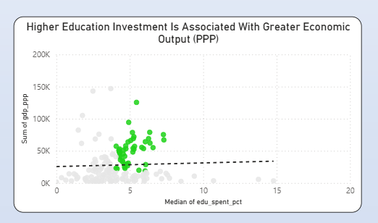
(High spend / lower PPP = inefficient)

- Regional Barriers: Efficiency is virtually absent in Sub-Saharan Africa and South Asia. This suggests that without supporting infrastructure and market openness, education spending becomes "dead-weight" spending.
2.2 The Wealth Disconnect (Top vs. Bottom)
By isolating the Top and Bottom 5 performers, we validate that current spending does not dictate current status:
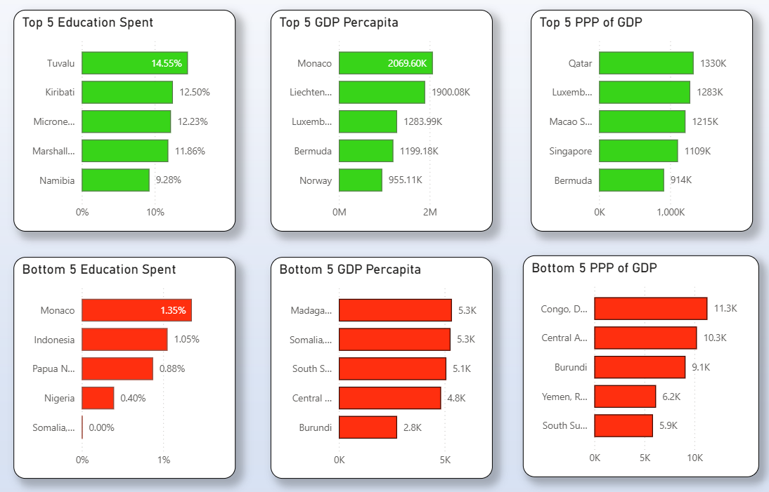
- The High-End: Top 5 nations by PPP (Qatar, Luxembourg, etc.) are absent from the top education spenders list.
- The Low-End: Conversely, systemic under-investment is almost universally associated with economic distress. Countries like Burundi and the Central African Republic rank in the bottom 5 for both spending and PPP, suggesting a "floor" of investment is required to avoid collapse.

3. Temporal Trends: The Decoupling Effect
3.1 10-Year Trend Analysis (2012–2022)
Investigating the relationship over time shows that educational investment is a "lagging" rather than a "leading" indicator:
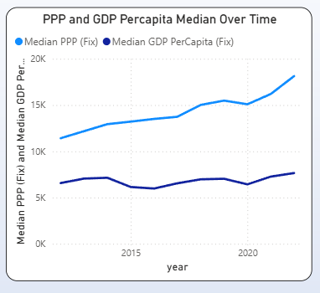
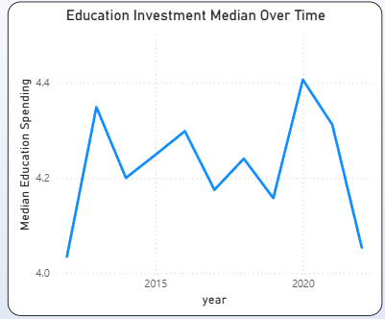

- Static Investment: Global education spending fluctuated within a narrow band (4.0% to 4.4%), eventually returning to 2012 levels.
- Dynamic PPP: During the same period, PPP was the most dynamic metric. The divergence confirms that the "human capital" cycle—from primary school to a high-productivity workforce—likely requires a 15 to 25-year window, far exceeding the 10-year data scope.

4. Final Conclusion & Data Limitations
4.1 The Final Verdict
The study confirms Hypothesis 3: Education is a critical but non-linear driver of wealth. The data suggests that for developing nations, education spending acts as a "floor"—necessary to prevent economic decline—while for developed nations, it acts as a "ceiling-raiser" only when paired with institutional stability.
4.2 Key Analytical Takeaways
- The 20-Year ROI Cycle: A 10-year window is insufficient to capture the full "human capital" lifecycle. The benefits of today’s investment may only manifest in the 2035–2045 data cycles.
- Efficiency vs. Volume: High spending without high efficiency suggests "dead-weight" loss. Policy-makers should focus on spending quality (outcomes) rather than just spending volume (% of GDP).
- Decoupling Reality: The 63% surge in global PPP despite stagnant education spending suggests that modern wealth is being driven by rapid technological adoption and global trade rather than traditional classroom investment.
4.3 Technical Note & Data Integrity
To maintain analytical accuracy, the following adjustments were made:
- Outlier Management: Financial anomalies (e.g., Monaco’s $2M GDP per capita) were normalized through synchronized scaling to prevent skewing the global median.
- Purchasing Power Realism: By prioritizing PPP over nominal GDP, the study successfully accounted for international cost-of-living differences, providing a more "human" view of economic standards.
4.4 Future Work & Expansion
To evolve this model from "Exploratory" to "Predictive," future iterations should incorporate:
- Corruption Perception Index (CPI): To test if institutional integrity is the missing link in the "Efficiency Gap."
- Broadband Access Metrics: To measure the impact of digital infrastructure on education ROI.
- Labor Market Alignment: Analyzing if the type of education (vocational vs. academic) correlates more strongly with GDP growth.

Hypotheses:

H0: There is no correlation between higher education investment and better economic conditions.

H1: Higher education investment leads to higher economic standards
H2: Countries with higher economic standards invest more in education
H3: Education is only one of the factors that influence higher economic standards.

- Weak Correlation & The Efficiency Gap: There is only a weak positive relationship between education investment and economic output. The Investment Efficiency rate stands at a low 21%, suggesting that spending is not a guaranteed driver of immediate wealth.
- The "Investment Effort" Paradox: A high concentration (43%) of countries that invest above the global median are trapped in lower economic groups. This indicates that these nations are making a significant fiscal effort that has yet to translate into high PPP.
- The Wealth Disconnect: The world’s wealthiest nations by PPP (e.g., Qatar, Singapore, Luxembourg) are notably absent from the top education spenders list. Conversely, the highest spenders (e.g., Tuvalu, Kiribati) belong to Lower and Middle-Income groups, proving that current spending levels do not reflect accumulated national wealth.
- Growth Decoupling: Over the last decade, PPP grew by 63% while the median education investment remained stagnant (~0% net growth). This divergence confirms that the global wealth surge in this period was fueled by factors other than increased educational spending.
Final Conclusion: The Complexity of Economic Return
While the data supports a positive influence of education on economic conditions, it rejects the idea of a simple, linear correlation. The study suggests two critical takeaways:
- Multifactorial Growth: Economic standards are influenced by a complex ecosystem of variables (infrastructure, political stability, trade) where education is a necessary but insufficient factor on its own.
- The Time-Horizon Limitation: A 10-year window is likely insufficient to capture the full ROI of education. Since the "human capital" cycle—from primary school to high-productivity workforce—takes 15 to 25 years, the economic benefits of today's investment may only manifest in decades to come.
Final Verdict: $H_1$ (Higher investment leads to higher standards) is partially supported as a long-term catalyst, but $H_4$ (Other factors dominate) is the primary driver of the observed 10-year economic trends.

